THE ROLE OF ε STRESS-INDUCED MARTENSITE IN Fe-Mn-Si SHAPE MEMORY BEHAVIOUR

BY

LEANDRU-GHEORGHE BUJOREANU, SERGIU STANCIU, MONICA NICOLETA LOHAN, NICANOR CIMPOEŞU, CIPRIAN LOHAN

Abstract It is well-known that simple shape memory effect, characteristic to Fe-Mn-Si based alloys, consists in the recovery of γ (f.c.c.) austenite by thermally induced transformation of ε (h.c.p.) stress-induced martensite. In the case of Fe-Mn-Si based shape memory alloys (SMAs), by means of optical and scanning electron microscopy as well as by tensile testing, the paper analyses microstructural characteristics and macroscopic evolution in force-deformation-temperature space. For this purpose, the formation and the morphology of ε martensite both by thermally-induced and stress-induced transformations is reported. After stress-induced formation of martensite, the occurrence of free-recovery and constrained-recovery simple shape memory effects is described via “uncoiling experiments” and stress variation during heating in elongated condition, respectively.

Keywords: Fe-base shape memory alloys, martensite, austenite, micrograph, recovery stress

2000 Mathematics Subject Classification: 53B25, 53C15

1. Introduction

Among shape memory alloys (SMAs) those based on Fe-30 Mn-6 Si (here after all concentrations will be in mass. %) represent the most promising candidates for applications, owing to their fair cost, workability and weldability [1]. The first commercial applications of this SMA system were pipe joints in civil engineering constructions made from Fe-28 Mn-6 Si-5 Cr [2]. Since these alloys typically experience simple shape memory effect (SME=unique recovery of “hot” austenitic shape during heating of a SMA to which a “cold” martensitic shape was previously induced), the governing mechanism consists in the thermally induced reversion of ε (hexagonal close-packed, h.c.p.) stress induced martensite (SIM) to γ (face centred cubic, f.c.c) austenite [3]. Owing to the great potential of Fe-Mn-Si based SMAs, intensive research has been performed in the quarter of century which succeeded their discovery in 1982 by A. Sato et al. [4]. Basically, it has been concluded that, in order to experience an elevate SME-value it is desirable that the structure of SMA, with optimum concentration within the range Fe-(28-34) Mn-(4-6,5) Si (%), includes a large amount of short thin lamellae of evenly distributed ε (h.c.p.) SIM [5].
However in a previous work it was pointed out that even a Fe-23.3 Mn-2.8 Si SMA experienced both free recovery and constrained recovery SME which were ascribed to the existence of about 57 % ε (h.c.p.) SIM plates after applying a permanent tensile strain of 4.3 % [6]. The present paper aims to bring more evidence on the formation and the morphology of ε martensite formed both by thermally-induced and stress-induced transformations.

2. Experimental Details

From a Fe-23.3 Mn-2.8 Si SMA, cast and processed as previously detailed [7] lamellar specimens were cut with the dimensions 1.25 x 0.3 x 100·10⁻³ m.
Free recovery SME was revealed, by means of cinematographic analysis, during the heating of coils obtained at RT on a 5·10⁻³ m-diameter rod.
After being cut and embedded into resign, the specimens were electro polished and etched with 10 % Nital solution, before being observed by optical microscopy (OM), both in undeformed state and after being elongated with 4.3 % (by means of a tensile testing machine) as well as to scanning electron microscopy (SEM) observations in deformed state.
Lamellar specimens, with active length between grips l₀ = 60·10⁻³ m, were subjected to tensile constrained recovery tests, according to a special experimental procedure described in a previous work [6].

3. Experimental Results and Discussion

Figs. 1 and 2 illustrate typical OM micrographs of the specimens in initial undeformed state, on longitudinal and transversal cross-sections, respectively.
On longitudinal plane, Fig. 1 shows only scarce ε martensite plates, more obvious in the detail shown in Fig. 1(b). However it is noticeable that these plates belong to a single martensite variant in each single crystalline grain of γ austenite. On transversal plane Fig. 2 reveals obvious fibering-forming tendencies (ascribed to multiple rolling passes) which confine the formation of ε martensite to longitudinal morphologies.
These aspects reveal that, in spite of hot forging, hot rolling and quenching, the specimen in undeformed state contains only a low amount of ε martensite.
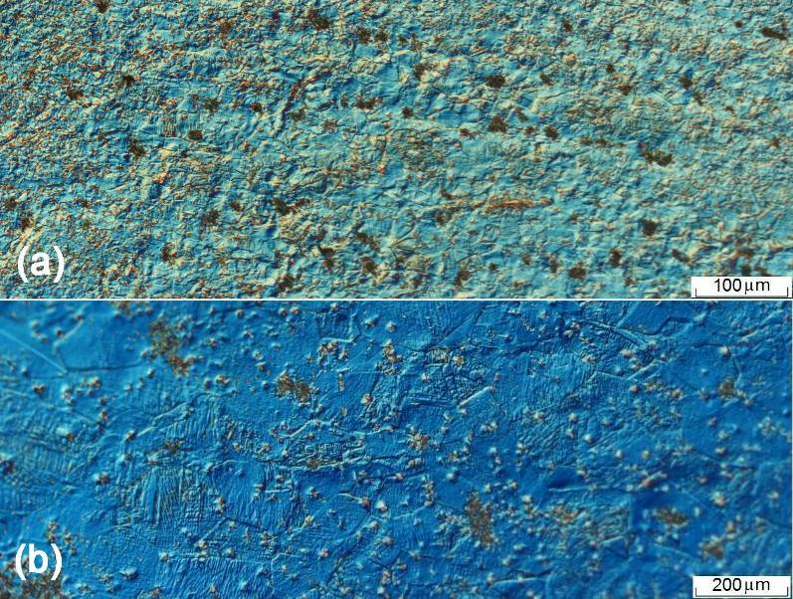
Fig. 1 OM micrographs on longitudinal cross-sections, of Fe-23.3 Mn-2.8 Si in undeformed state: (a) typical general aspect; (b) detail of γ austenite grains containing ε martensite plates with unique orientation

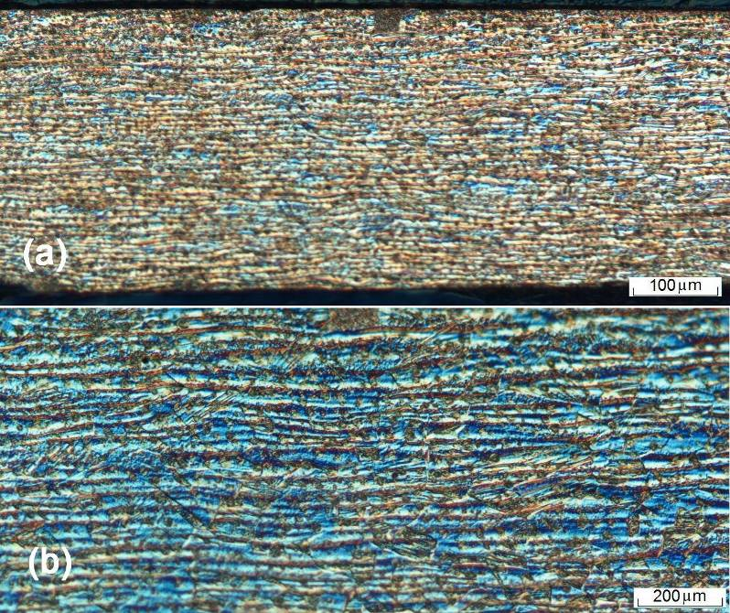
Fig. 2 OM micrographs on transversal cross-sections, of Fe-23.3 Mn-2.8 Si in undeformed state: (a) typical general aspect revealing fibering-forming tendencies, due to multiple rolling passes; (b) details of elongated γ austenite grains with ε martensite plates

In elongated state, the presence of ε martensite plates becomes more obvious in the typical OM micrographs from Fig. 3(a). Fig. 3(b) shows that the plates became finer, with multiple orientations within the same austenite grain and the areas of retained austenite were reduced.
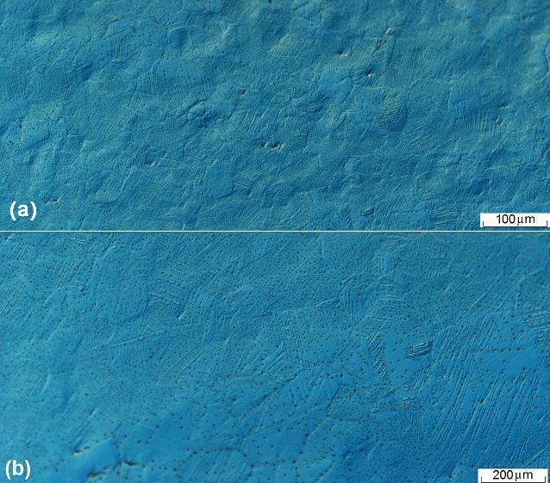
Fig.3 OM micrographs of elongated state with 4.3 % permanent strain, on longitudinal cross-section: (a) typical general aspect; (b) detail of γ austenite grains with 2 orientations of ε SIM plates

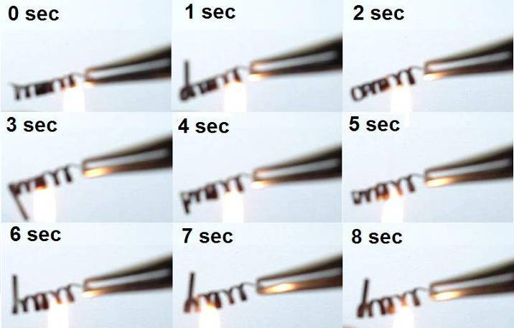
In order to reveal the existence of free recovery SME by means of the so-called “uncoiling experiment” [8], coiled specimens were heated until no further shape change was noticed. Fig. 4 illustrates 9 frames, recorded every second during horizontal uncoiling. Unlike β- type SMAs, the γ-type alloy under study didn’t experience complete uncoiling. Since a complete turn was performed during 5 sec, the average uncoiling rate has been determined as 12 rot. / min.
Fig. 4 Horizontal uncoiling due to free recovery SME of a Fe-23.3 Mn-2.8 Si lamellar specimen

Fig. 5 illustrates the typical stress-strain-temperature variation, during the first three tensile constrained recovery cycles each of them performed after permanent strain increases with approx. 1.1 %.
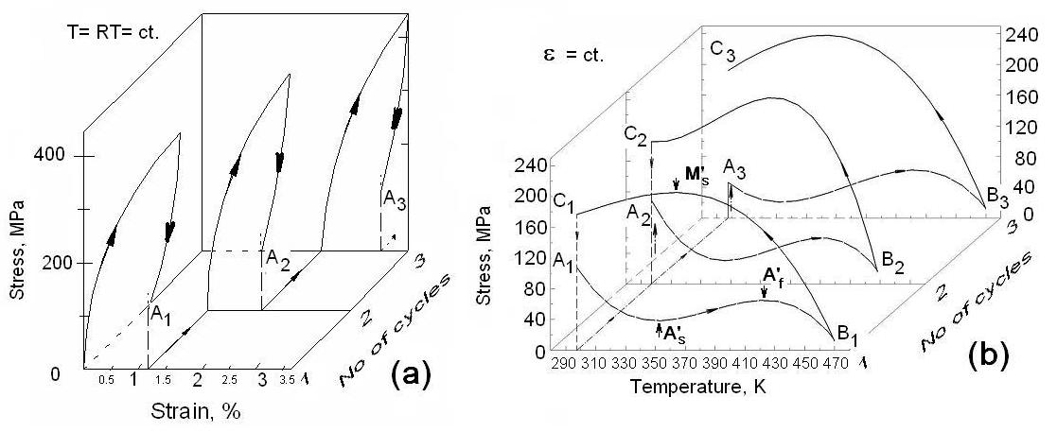
Fig. 5 Illustration of tensile constrained recovery behaviour of Fe-23.3 Mn-2.8 Si SMA lamellar specimens: (a) stress-strain variation at room temperature; (b) stress-temperature variation at constant strain

It is noticeable that both stress-strain variation at room temperature (RT), from Fig. 5(a) and stress-temperature variation at constant strain in each cycle (corresponding to the strains of points A_{1, 2, 3}, from Fig. 5(b) are fairly reproducible during the three cycles.
The stress-temperature evolution is consistent with the four stage stress variation curve reported in literature. Thus, on heating, stress decrease occurs due to thermal expansion, stress increase corresponds to ε→γ transformation, (which means that the minimum and the maximum give the approximate positions of A’_{s} and A’_{f}, respectively and heating proceeding causes a new stress decrease due to thermal expansion. On cooling, stress increased by thermal contraction and partially decreased indicating the onset of γ→ε transformation, (which means that the maximum corresponds to M’_{s}) [9].

4. Conclusions

1. After applying 4.3 % permanent strain ε SIM was formed with multiple plate variants.
2. The formation of ε SIM and its reversion on heating enabled the occurrence of free-recovery SME with a rate of 12 rot. /min and of tensile constrained-recovery SME, which was reproducible during 3 cycles after consecutive increases of permanent strain with about 1.1 % per cycle.

Acknowledgements. Scientific and technical support was kindly provided by Dr. Takahiro S a w a g u c h i and MSc Motomichi K o y a m a. Financial support was offered by UEFISCU by means of the research grant PN II - ID 301 - PCE - 2007 - 1, contract no. 279/ 01.10.2007.

Submitted: “Gh. Asachi” Technical University from Iaşi,
Accepted: Faculty of Materials Science and Engineering
Bd. D. Mangeron 61A, 700050 Iaşi, Romania
e-mail: lgbujor@tuiasi.ro

R E F E R E N C E S

1. M u r a k a m i M., S u z u k i H., N a k a m u r a Y., Effect of Si on the Shape Memory Effect of Polycrystalline Fe-Mn-Si Alloys, Transactions ISIJ, 27, B-87, (1987).
2. O t s u k a H., Y a m a d a H., M a r u y a m a T., T a n a h a s h i H, M a s u d a S., M u r a k a m i M., Effects of Alloying Additions on Fe-Mn-Si Shape Memory Alloys, ISIJ International, 30(8), 674-679, (1990).
3. S a t o A., C h i s h i m a, E., S o m a K., M o r i T. Shape Memory Effect in γ↔ε Transformation in Fe-30 Mn-1 Si Alloy Single Crystals, Acta metallurgica, 30 , 1177-1183, (1982)
4. M a k i, T., Ferrous Shape Memory Alloys, In Shape Memory Materials, (Otsuka K., Wayman C. M. Eds.), 117, Cambridge University Press, 1988
5. K a j i w a r a S., Ferrous Shape Memory Alloys, Materials Science and Engineering A 273-275, 67(1999)
6. B u j o r e a n u L. G., D i a V., S t a n c i u S., S u s a n M., B a c i u C., Study of the Tensile Constrained Recovery Behavior of a Fe-Mn-Si Shape Memory Alloy, accepted for publication in European Physical Journal. Special Topics, 147 (2008)
7. B u j o r e a n u L. G., S t a n c i u S., D i a V., Microstructural Changes Occurring During the Conventional Processing of Fe-Mn Based Shape Memory Alloys, Bul. Ins. Polit. Iaşi, LIII (LVII), 1, s. Ştiinţa şi Ingineria Materialelor, 21-26, (2007)
8. W a y m a n, C. M. – Deformation, Mechanisms and Other Characteristics of Shape Memory Alloys, In Shape Memory Effects in. Alloys., (Perkins, J., ed.), 1, Plenum Press, New York, 1975
9. D o n g Z. Z., K a j i w a r a S., K i k u c h i T., S a w a g u c h i T., Effect of pre-deformation at room temperature on shape memory properties of stainless type Fe–15Mn–5Si–9Cr–5Ni–(0.5–1.5)NbC alloys, Acta Materialia 53, 4009-4018 (2005)

ROLUL MARTENSITEI ε INDUSĂ PRIN TENSIUNE ÎN COMPORTAMENTUL DE MEMORIA FORMEI AL ALIAJELOR Fe-Mn-Si

(Rezumat)

Este binecunoscut faptul că efectul simplu de memoria formei, characteristic aliajelor pe bază de Fe-Mn-Si, constă din retransformarea în austenită γ (c.f.c.), prin intermediul transformării induse termic, a martensitei ε (h.c.) indusă prin tensiune. În cazul aliajelor cu memoria formei (AMF) pe bază de Fe-Mn-Si, lucrarea analizează caracteristicile microstructurale şi evoluţia în spaţiul forţă-deformaţie-temperatură, prin intermediul microscopiei optice şi electronice cu baleiaj precum şi al încercării la tracţiune. În acest scop, este prezentată formarea şi morfologia martensitei ε, atât prin transformări induse termic cât şi prin transformări induse prin tensiune. După formarea martensitei induse prin tensiune, este descrisă apariţia efectelor de memoria formei cu revenire liberă şi cu revenire reţinută, prin intermediul „experimentelor de despiralare” şi respectiv al variaţiei tensiunii în timpul încălzirii în stare alungită.

